Gitflow usando la extensión git graph:

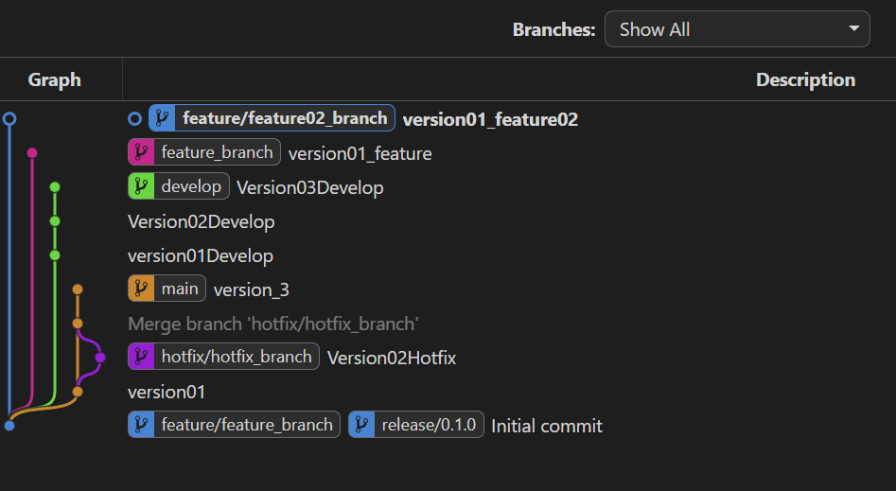

README de GitHub:

https://github.com/rhbeltran/rhbeltran/blob/main/README.md